Playing with Fido – Planning Document

# Description

For my capstone project, I will be building an experience where you are a person in your backyard who is playing with your dog Fido. In the experience the player will be doing various things with the Fido like playing fetch, petting him, feeding him, etc. As the player plays with Fido, they will see that his love meter fills and when it reaches the end, there will be a celebration.

# Features / Dependencies

## 3D Models / Animations (References)

1. Dogs

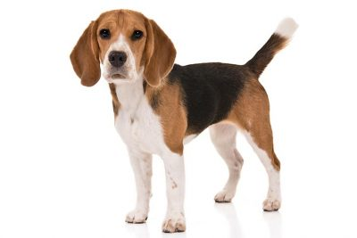

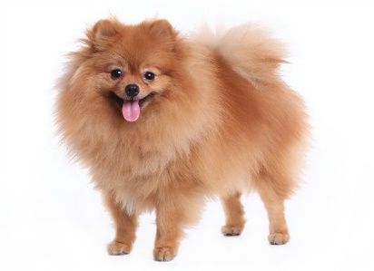

1. Backyards

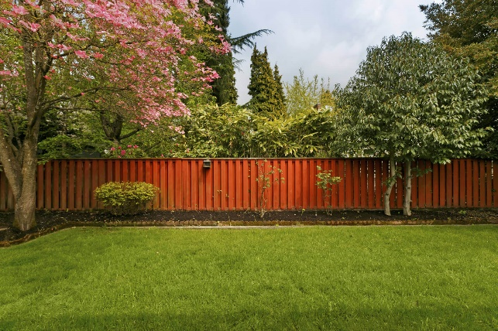

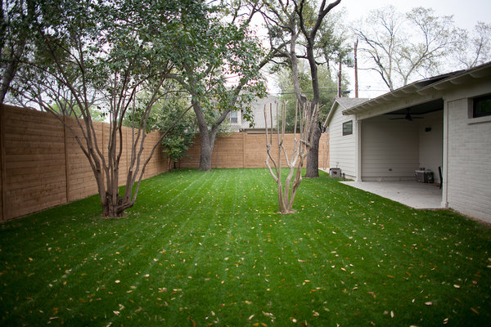

1. Fences

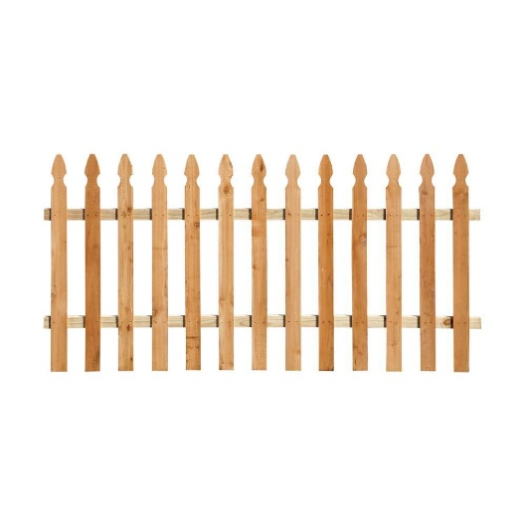

1. Trees

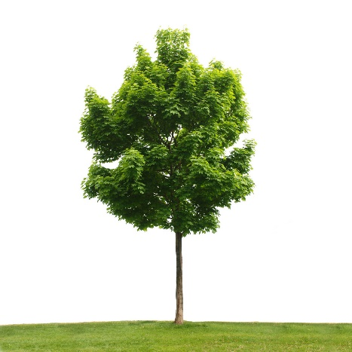

## Game Loop

1. Player loads into the scene
2. Player moves using teleportation and sees that the dog follows
3. Player interacts with dog (and sees love meter raise)
   1. Pet
   2. Fetch
   3. Tug of War
   4. Feed
   5. Issue Voice Commands
   6. Clean Poop?
4. Player continues until love meter is full
5. Player sees dog celebrate
6. Player exits scene

## Other Effects

1. Particle Effects for celebration
2. Spatial sound clips to make it sound like you are in a backyard: birds in tree, neighbor mowing, etc.
3. Song clip for celebration
4. Navigation Mesh that dog uses to move around

# Scoping

## 3D Models / Animations

1. Create Dog Model and Animations
   1. **Revised: Will use this package from Unity Asset Store (https://assetstore.unity.com/packages/3d/characters/animals/dog-package-71282)**
2. Create Environment models:
   1. House
      1. **Revised: Will use this package from Unity Asset Store (https://assetstore.unity.com/packages/3d/environments/low-poly-buildings-lite-98836)**
   2. Trees & Fence
      1. **Revised: Will use this package from Unity Asset Store (https://assetstore.unity.com/packages/3d/environments/low-poly-free-pack-58821)**
3. Create models for items to play fetch with
   1. Soccer Ball
      1. **Using this asset from unity asset store: (https://assetstore.unity.com/packages/3d/low-polygon-soccer-ball-84382)**
   2. ~~Tennis Ball~~
      1. **Don’t think I’ll need multiple balls**
   3. ~~Bone~~
      1. **Removed from scope**

## Game Loop

1. Player loads into the scene
2. Player moves using teleportation and sees that the dog follows
3. Player interacts with dog (and sees love meter raise)
   1. Pet
   2. Fetch
   3. ~~Tug of War~~
      1. **Revised: Not sure how well this would work when the player can’t feel the dog. Removing from scope.**
   4. ~~Feed~~
      1. **Revised: Not quite sure how to implement this. Removing from scope.**
   5. Issue Voice Commands
   6. ~~Clean Poop?~~
      1. **Revised: Would use the same mechanic as fetch. Removing from scope.**
4. Player continues until love meter is full
5. Player sees dog celebrate
6. Player exits scene

## Other Effects

1. Particle Effects for celebration
   1. **Will use effects from this asset in unity asset store: https://assetstore.unity.com/packages/vfx/particles/cartoon-fx-free-109565**
2. Spatial sound clips to make it sound like you are in a backyard: birds in tree, neighbor mowing, etc.
   1. **Will find free sound clips online**
3. Song clip for celebration
   1. **Will find a free sound clip online**
4. Navigation Mesh that dog uses to move around